2022-2023 Social Impact Initiative Kick-Off Session
Brainstorming Questions
For the purpose of having a more efficient and informative Social Impact Initiative (SII) Kick-Off session, please think about the questions below and prepare some answers before joining the meeting. For confirmed sponsors, you are highly recommended to revert the answers back to me at least one day before the meeting for our brainstorm discussion. For potential sponsors, you are also welcomed to join the brainstorm discussion if you have the answers ready with you.

- Among the 17 SDG goals proposed by the United Nations, which goals do you think we can help China to maintain/achieve through SII?
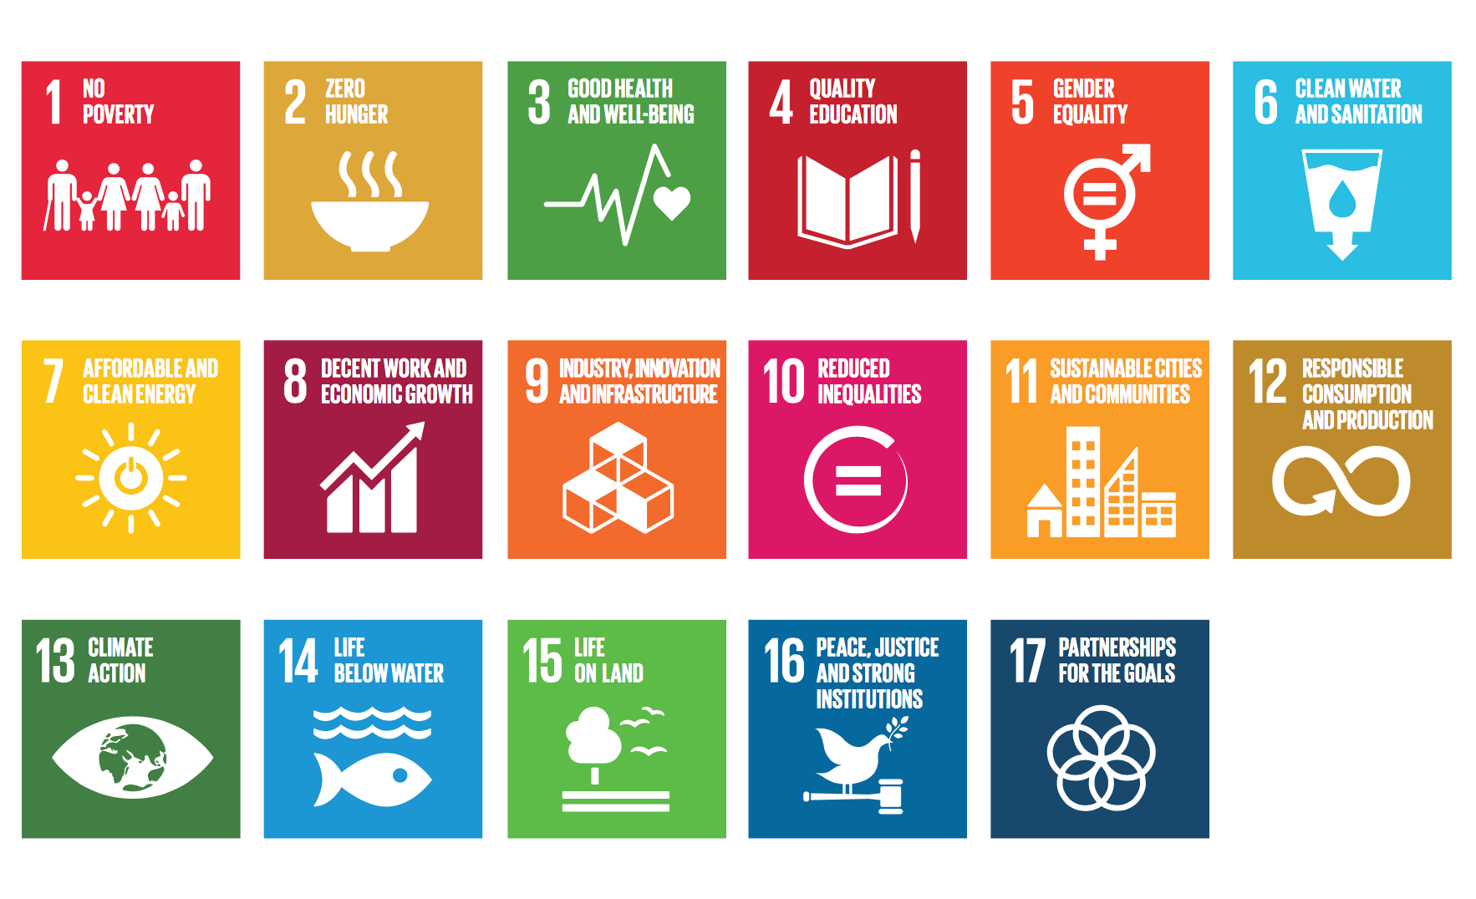

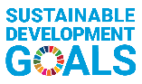

- What is your global strategy on ESG transformation and sustainable development? What is the impact on your business operations in China?

- What are the programs/projects your company is currently running that are relevant to SII themes (Digital Economy, Green Development, and Rural Revitalization)?

- Please name the stakeholders you are interested in engaging with in both public institutions (government, universities, think tanks, international organizations, media etc.) and private institutions (companies, industry associations, NGOs, media etc.)

- Which Chinese companies/organizations are you interested in building connection with to help your business/EGS programs in China?

- Any other idea/suggestions/expectation for SII?

