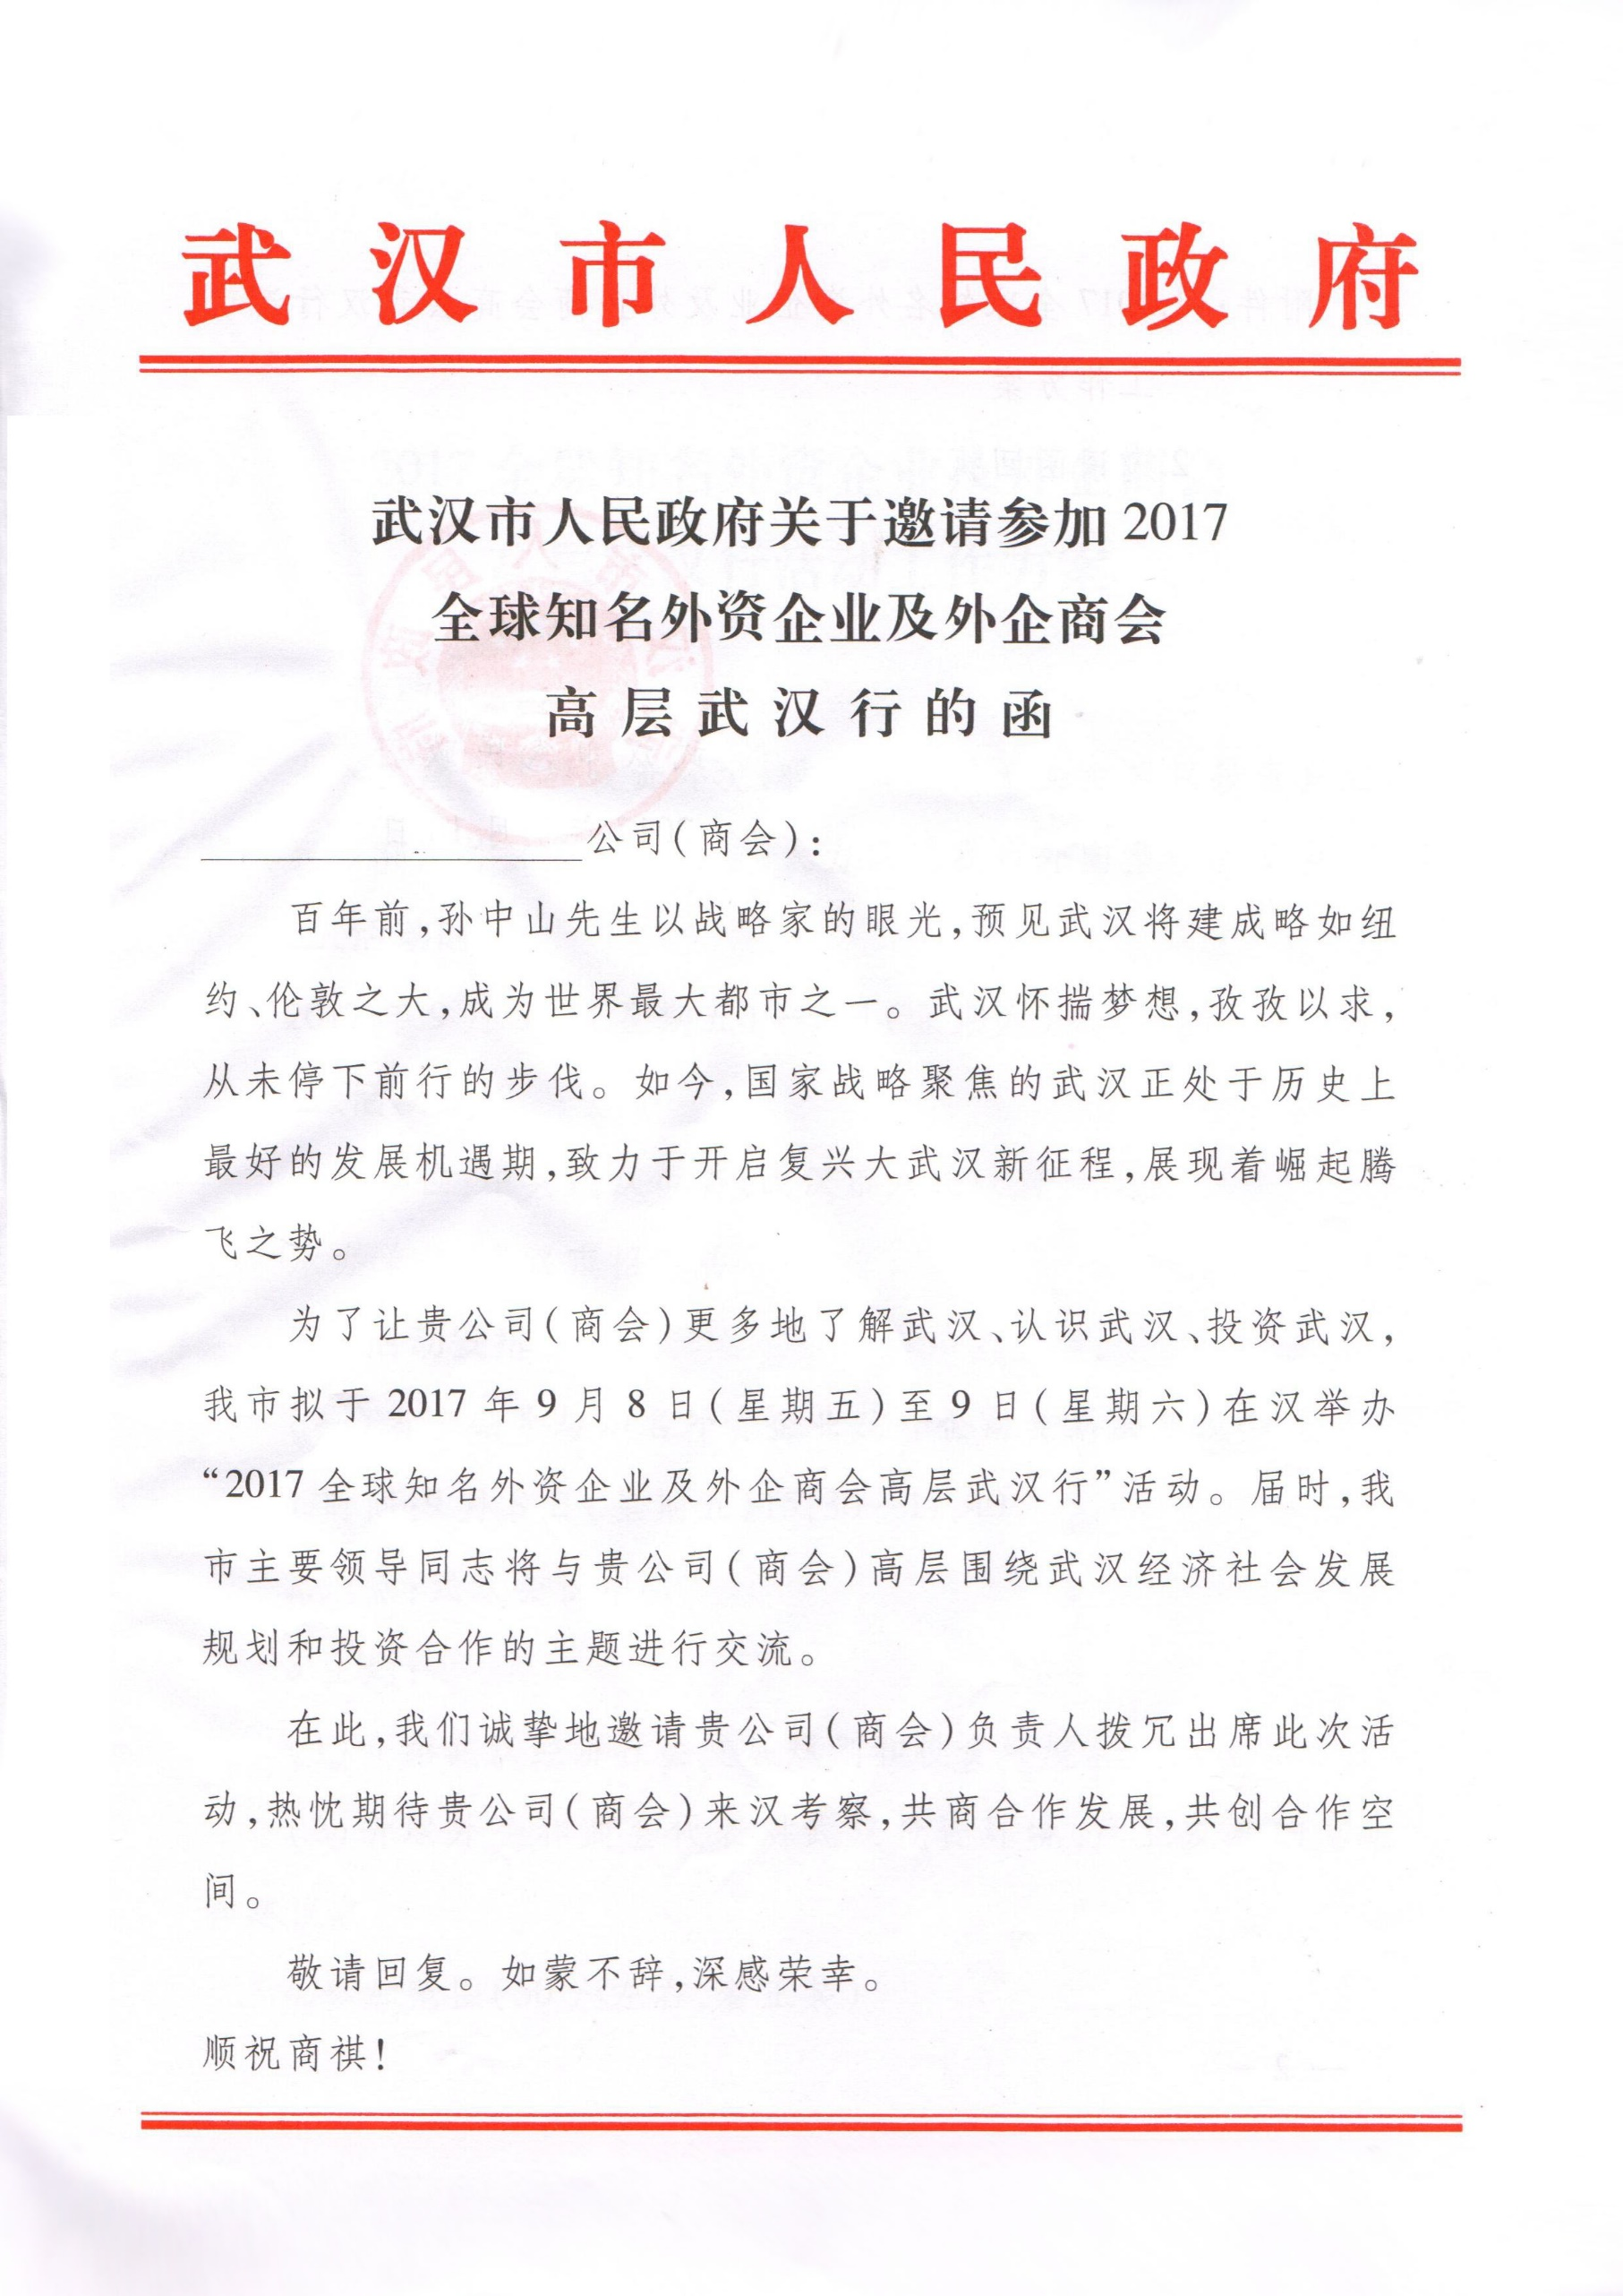

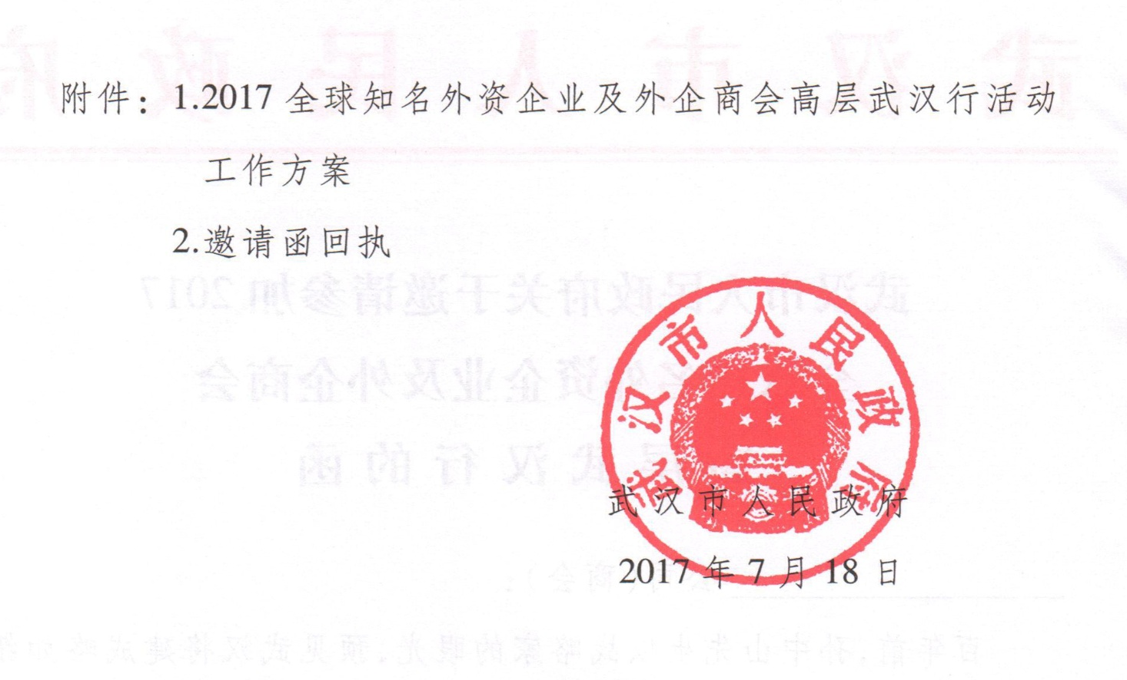
附件 1

2017全球知名外资企业及外企商会
高层武汉行活动工作方案

一、活动宗旨
进一步宣传武汉投资环境，吸引知名外资企业来汉投资兴业，提高我市利用外资规模和质量，大力促进我市外向型经济发展。
二、活动时间
2017年9月8日（星期五）—9日（星期六）
三、活动组织
主办单位：中共武汉市委、武汉市人民政府
承办单位：武汉市招商局
四、活动安排
（一）省市领导与知名外资企业及外企商会高层座谈会
1．时间：9月8日（星期五）15:30—17:40
2．地点：武汉会议中心
3．主题:
（1）介绍武汉经济社会发展规划和投资环境。
（2）听取外企和商会代表对武汉投资环境、产业发展的意见 和建议。
4．参加范围（50人左右, 着正装）
（1）省市领导；
（2）市有关部门、各区负责人；
（3）境外世界500强企业、全球知名外资企业和外企商会高层代表；
（4）新闻媒体。
5．会议议程:
（1）主持人介绍与会嘉宾；
（2）播放武汉招商宣传片；
（3）参会外企及商会代表发言；
（4）省、市领导讲话。
（二）省市领导与知名外资企业及外企商会高层餐叙
1. 时间：9月8日（星期五）17:50—19:00
2. 地点：武汉会议中心
3. 参加范围：参加高层座谈会全体人员
（三）考察活动
1. 时间：9月9日（星期六）
2. 参加范围：全体参会外企及商会代表
3. 行程安排
09:30—11:30考察武汉开发区
13:30—15:30 考察东湖开发区
附件 2
邀请函回执

企业名称：
出席人员 | 姓名： | 职务： | 电话：
随行人员 | 姓名： | 职务： | 电话：
 | 姓名： | 职务： | 电话：
拟入住酒店名称：
请于8月18日前将回执发送至邮箱434531989@ qq.com或传真至027－82796659，欢迎随时联系武汉市招商局（联系人：刘莎电话：82796659 15972118958）
我们推荐的酒店：☆☆☆☆☆
武汉香格里拉大酒店（订房电话：027－85806868 地址：武汉市江岸区建设大道700号）
武汉马哥孛罗酒店（订房电话：027－82778888 地址：武汉市江岸区沿江大道159号武汉时代广场）
武汉会议中心（订房电话：027－82300888 地址：武汉市江岸区惠济路38号）。

Invitation

:

One hundred years ago, Mr. Sun Yat-sen foresaw that Wuhan would become one of the largest metropolises in the world, about the same size as New York City or London with his forward-looking strategic view. Wuhan, striving after the dream diligently, has never stopped moving forward. Nowadays, as the focus of multiple national strategies, Wuhan is embracing unprecedented opportunities, committing itself to starting a new journey of the revitalization, and gathering momentum in rapid development.

2017 Wuhan Tour for Executives of World-Renowned Foreign Companies and Chambers of Commerce is scheduled to be held by Wuhan Municipal People’s Government in Wuhan from September 8 to September 9, 2017. This event aims to introduce Wuhan more profoundly and discuss potential cooperation opportunities with your company. Leaders of the provincial and municipal government will discuss with your company on socioeconomic development of Wuhan and future investment cooperation.

Hereby, we sincerely invite the global vice president or the CEO in PRC region of your company to participate in this event. We warmly welcome your presence and look forward to cooperating with you for joint development.

It will be our great honor to receive your reply, and your attendance will be highly appreciated.

Sincerely,

Wuhan Municipal People’s Government
July 18, 2017

Attachments:
- Schedule of 2017 Wuhan Tour for Executives of World-Renowned Foreign Companies and Chambers of Commerce
- Acknowledgement

Attachment I

Schedule of 2017 Wuhan Tour for Executives of
World-Renowned Foreign Companies and Chambers of Commerce

- Aims of Event
This event aims to further promote the investment environment of Wuhan, to attract world-renowned foreign companies running business in Wuhan, to boost the size and quality of utilization of foreign investment, and to promote the outward-oriented economy of Wuhan.

- Date
September 8- September 9, 2017

- Organizations
Hosted by: CPC Wuhan Municipal Committee and Wuhan Municipal People’s Government
Organized by: Wuhan Investment Promotion Bureau

- Event Schedule
  - High-level Dialogue
    - Time: 3:30 p.m.– 5:40 p.m. (September 8, 2017)
    - Venue: Wuhan Conference Center
    - Theme：
      - Introduce socioeconomic development and investment environment of Wuhan.
      - Listen to suggestions given by representatives from foreign companies and chambers of commerce
    - Attendees (approximate number of attendance: 50)
Dress Code: Formal
      - Leaders of the provincial and municipal government
      - Heads of related government departments and districts
      - Representatives of executives from world-renowned foreign companies and chambers of commerce
      - News media
    - Conference Agenda
      - Introduction of attendees
      - Display of Wuhan Investment Promotion Video
      - Speech delivered by representatives from foreign companies and chambers of commerce
      - Speech delivered by leaders of the provincial and municipal government

  - Welcome Banquet
    - Time: 5:50 p.m.– 7:00 p.m. (September 8, 2017)
    - Venue: Wuhan Conference Center
    - Attendees: All participants in the high-level dialogue

  - Business Investigation
    - Date: September 9, 2017
    - Attendees: Representatives from foreign companies and chambers of commerce
    - Agenda
      - 9:30 a.m. – 11:30 a.m. Business investigation in Wuhan Economic and Technological Development Zone
      - 1:30 p.m. – 3:30 p.m. Business investigation in Wuhan East Lake High-Tech Development Zone
Attachment II
Company Name:
Representative | Name： | Gender： | Title： | Phone Number： | E-mail：
Entourage | Name： | Gender： | Title： | Phone Number： | E-mail：
 | Name： | Gender： | Title： | Phone Number： | E-mail：
Hotel Option：
Acknowledgement

Hotel recommendation:

  - Shangri-La Hotel, Wuhan
    - Phone Number: 027-85806868
    - Address: No.700 Jianshe Avenue, Jiang’an District, Wuhan, China

  - Marco Polo Hotel, Wuhan
    - Phone Number: 027-82778888
    - Address: No.159 Yanjiang Avenue, Jiang’an District, Wuhan, China

  - Wuhan Conference Center, Wuhan
    - Phone Number: 027-82300888
    - Address: No.38, Huiji Road, Jiang’an District, Wuhan, China

Please send this acknowledgement via either e-mail or fax before August 18. The e-mail address is 434531989@qq.com and the fax number is 027-82796659. You are very welcome to contact Wuhan Investment Promotion Bureau.

Contact: Liu Sha
Phone number: 027-82796659
Cell phone number: 15972118958

